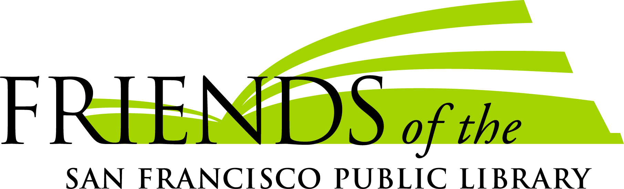

JOB DESCRIPTION
ADMINISTRATIVE ASSISTANT

Status: Full time, hourly nonexempt
Reports to: Executive Director

Mission
Friends is a diverse community of individuals, families and institutions who love our San Francisco Public Library and make it exceptional. We champion free public access to information, resources and opportunities for all people. Our mission is to strengthen, support and advocate for a premier public library system in San Francisco.

Summary of Responsibilities
This person is responsible for performing administrative support tasks for the Executive Director, the Development staff team and Board of Directors. Work performed may include a broad range of complex responsibilities involving confidential or technical information and require the use of judgment and discretion in completing assignments.

Deliverables
General Administrative Duties
- Greet and direct visitors to appropriate staff
- Answer main phone line, respond to callers, and direct calls to staff
- Maintain literature and related materials at front desk, reception area and mailing area
- Handle shipping/mailing needs, including sorting incoming mail, deliveries, and occasional pic up and delivery
- Maintain administrative files & archives
- Monitor and order supplies for the office
- Maintain conference room schedule and set and clean up for meetings
- Additional clerical, photocopying, scheduling, and/or administrative projects including updating staff organization charts, staff contact lists, check depositing and bank runs, maintaining system for recognizing staff and board birthdays, and other duties as assigned.
For Executive Director
- Assist with correspondence and administrative/organizational tasks
- Work directly with ED to support projects and events
- Attend certain meetings with ED to take notes
- Other special projects as assigned
Board of Directors
- Maintain meeting schedule, communicate with Board regarding meetings, and prepare agendas and packets
- Take minutes at all Board meetings
- Assist with annual meeting and board retreat
- Maintain Board records
- Post and maintain information on the Board’s One Drive
For Development staff team:
- Process gifts received: batching, distribution of information, and deposits
- Assist with development department mailings
- Assist with data entry in Raiser’s Edge
- Assist with fundraising events, including mailing invitations, tracking rsvps, taking notes at planning meetings, ordering food and catering, organizing decorations and material

Friends Mission and Values & Community Relationships
- Positively represent the mission and community value of Friends in meetings, conversations and/or presentations with members of the community, donors and partners.
- Understand and be able to describe all of the Friends programs: direct financial support to the Library; indirect support in financial management and investment; book donation and retail sales; the Community Literacy Program, and green conversation goals.
- Promote and articulate the goals and messaging of Friends’ special fundraising campaigns and bookselling initiatives

Internal Relations - Teamwork & Collaboration
- Participate positively and productively in monthly Communications meetings and in Advancement team meetings upon request
- Assist Advancement team and Book Operations staff in promoting and organizing Friends signature events, including the Big Book Sale.

Other requirements:
- Must be able to handle diverse tasks simultaneously.
- Able to work independently and maintain a high degree of diplomacy while working with vendors, donors, agency and library staff, volunteers and members of the public

Friends of the San Francisco Public Library is an Equal Opportunity Employer, acting without regard to the fact or perception of their race, creed, religion, color, ancestry, national origin, age, sex, sexual orientation, gender identity, domestic partner status, marital status, disability, weight, height or AIDS/HIV status.
(updated April, 2018)

